**Sales Analysis Report Using MySQL and PowerBI**

**Problem Statement:** The sales head of a national-level company is having issues getting insights into the sales that are happening across the country. Sales for his company are declining every year, and he is worried about it. Whenever he asks for reports from regional managers, they send him lots of Excel files, and he is not able to draw any conclusions from those files. All of the company data gets stored on a MySQL server, and he is looking to get an automated dashboard from that data, which he can see at any moment and anywhere to get sales insights.

In this project, I first uploaded the data to the MySQL workbench and ran some queries to get insights from it. I have created a stored procedure to get the data for the particular market and have also created a view to show my skills in MySQL. After this, I created the data model in Power BI and then cleaned the data using a Power query. I have used this clean data to build a dashboard using Power BI reports.

**Attached Files**

[**MySQL Database File**](https://drive.google.com/file/d/1SQwcLMKkuR0S6tgu1i88uZOznv4OBpsd/view?usp=drive_link) **:** Link for MySQL Database file which I used to create a database on MySQL Workbench.

[**MySQL Queries File**](https://drive.google.com/file/d/1MsVxy9zMaJ8D2CupGomFL12JH8uzOWEK/view?usp=drive_link) **:** This File contains all the queries which I have used to get insights using SQL language.

[**Dashboard Link**](https://drive.google.com/file/d/1nHVP7KPaC9e34cDm6ae8niWWXiIRV2fg/view?usp=drive_link) **:** This is the link to the power BI Dashboard which I built using the dataset.

**Data Overview :-**

This sales MySQL database consists of five tables:-

* Transactions
* Products
* Customers
* Markets
* Date

**Power BI Data Model :-**

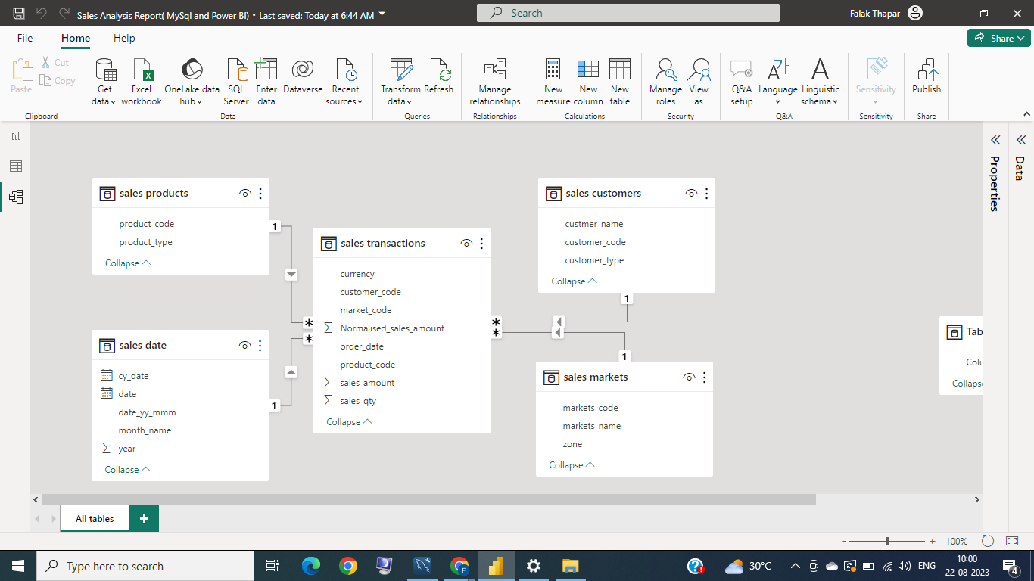

**Insights from MySQL Workbench :-**

Data Analysis Using SQL

1. All tables in sales database.

– Here, In transactions table we have some transactions which are not in INR so we will need to convert them to INR.

2. Total number of transactions.

3. Number of transactions and sum of sales from different markets

4. All the transactions from particular market

– I have created a stored procedure to get insights for differnt markets

5. Transactions which do not have INR as currency

– Here I would not like to hamper the original data so I have created a view.

6. Transations in 2020 joined by dates table.

7. Checking revenue for different years to see revenue pattern.

– here, we can see that sales increased in 2018 but then decreased on 2019 and 2020.

**Data Cleaning Steps :-**

**To clean the data in order to get reliable insights. I have used Power Query.**

* **The steps that I have performed are:**
* **I removed the market locations that were outside of India.**
* **The transactions table consisted of some values in USD and also some repetitive values. I have removed repetitive values and converted USD values to INR.**
* **The sales amount had many 0 and -1 values, which I filtered as false entries in the data.**

**Data Report :-**

**I have created a Power BI report using Power BI Desktop and have uploaded this report to the Power BI Service. Now, the sales head at the national level can look at insights very easily. I have automated data refresh and made the mobile view of the report so that he can access the data report anywhere, even if he is travelling and does not have his laptop with him.**

**This can help him make important data-driven decisions in order to improve revenue. He can also subscribe to this report and send it to managers at regional levels.**

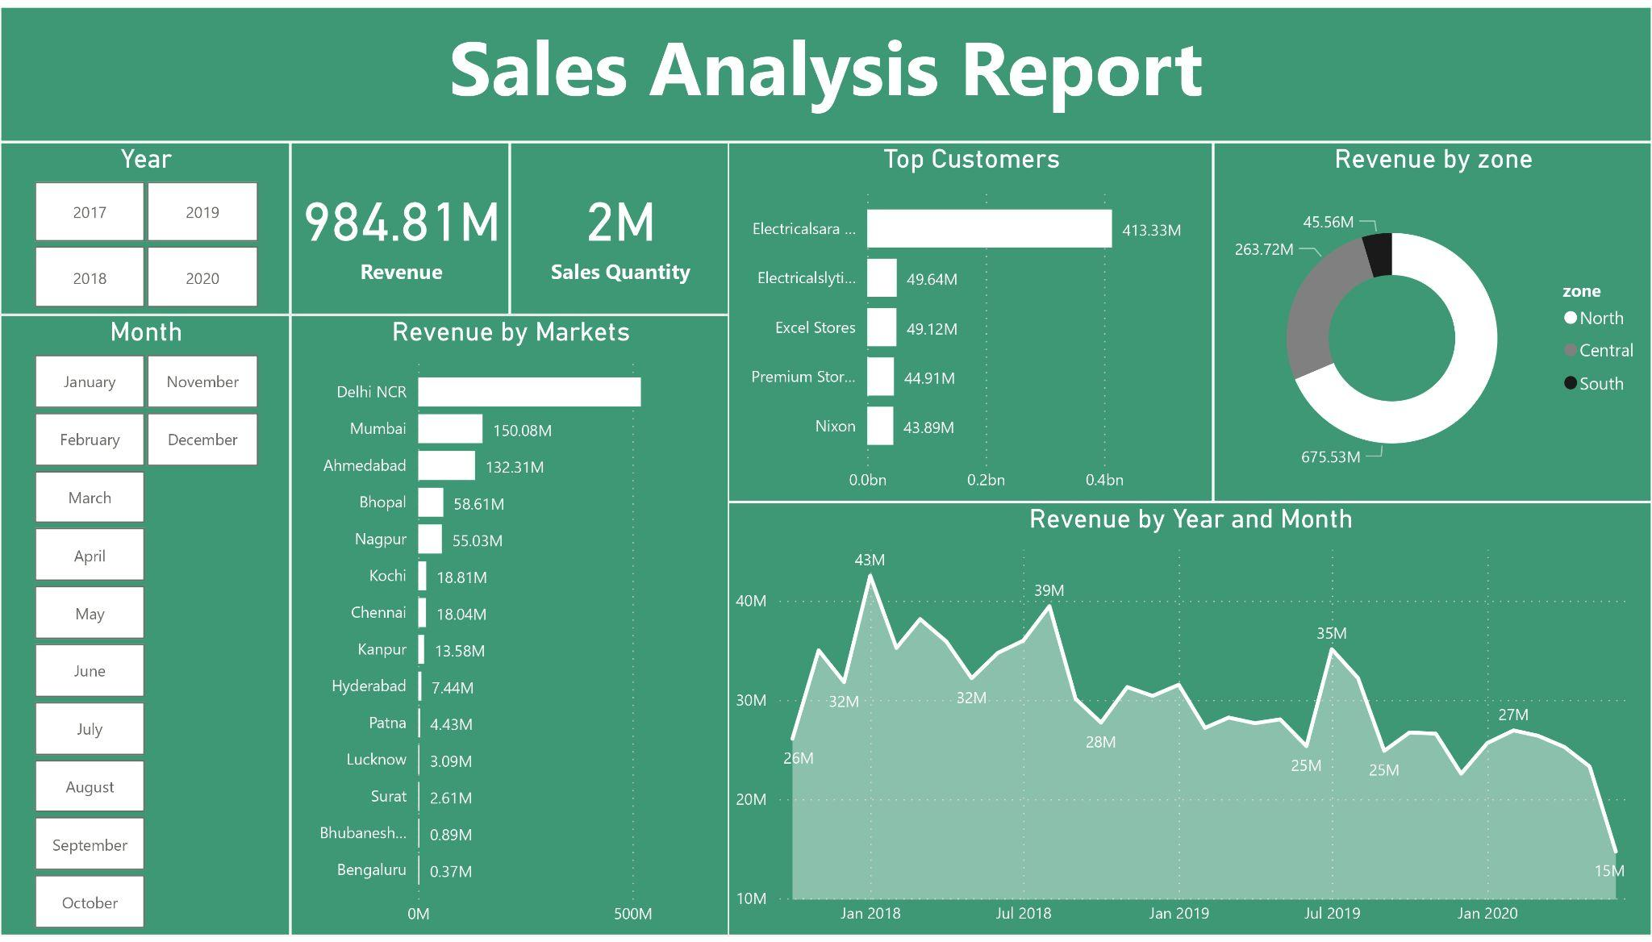

**Mobile View Report** :-

